**File manager tests**

Input:

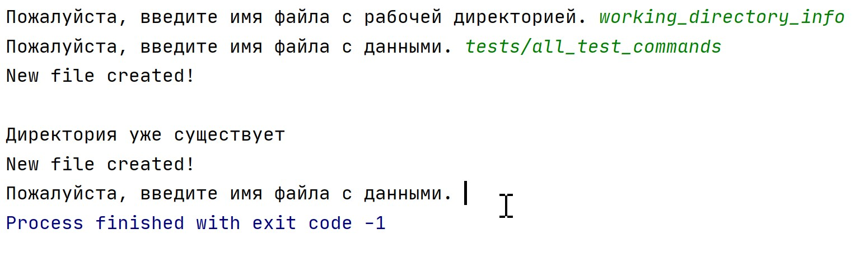

Res:

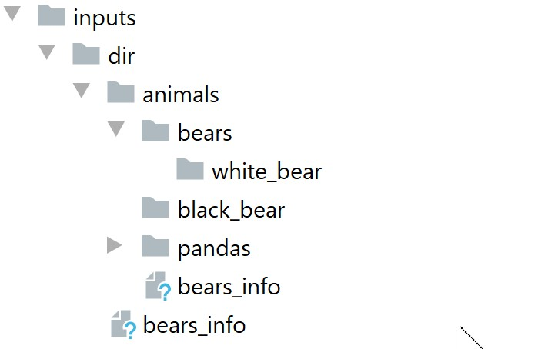

working_directory_info:

C:\Users\ACER\Desktop\FA\UNIX\FA_file_manager\file_manager\inputs\dir

tests/all_test_commands:

mkdir /animals  
mkdir /birds  
mkdir /animals/bears  
cd /animals/bears  
mkdir /white_bear  
cd .  
mkdir /black_bear  
cd .  
rmdir /birds  
touch bears_info  
cat bears_info  
mkdir /animals  
cp bears_info /animals  
touch pandas_info  
mkdir /animals/pandas  
mv pandas_info /animals/pandas  
rename /animals/pandas/pandas_info /animals/pandas/cute_pandas_info